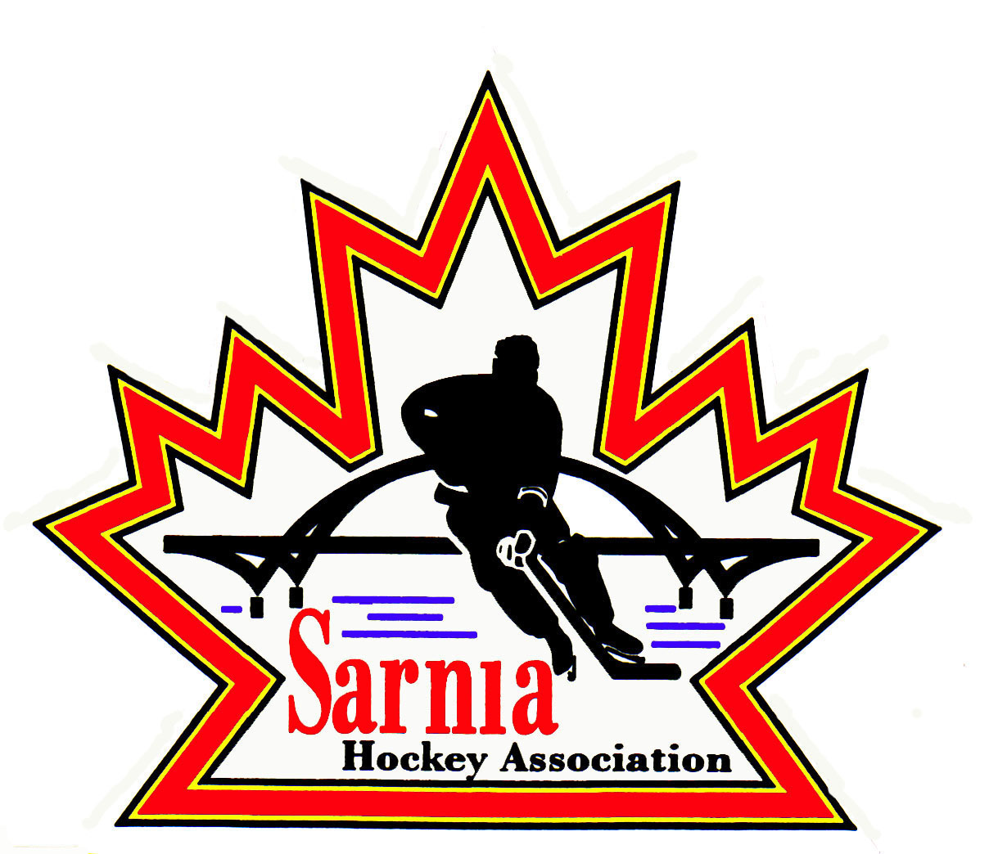

Sarnia Hockey Association

Minutes | Date: MARCH 4, 2025 | time 7:00 pm

Meeting called by | Paul Walsh, President
Type of meeting | Regular
Secretary | Kelly Lane, Recording Secretary

Welcome | Paul Walsh, President, and meeting Chair welcomed everyone and called the meeting to order at 7:08 pm.

ATTENDANCE | Andrew Beasley, Jerry Bernardo, Emily Brown, Darren Chevalier, Jeff Fogal, Pat Forbes, Dan Hunt, Kelly Lane, Linda Lauzon, Don McGugan, John Mellor, John Ritchie, Wayne Scarrow, Kevin Taylor, Tim Turner, Paul Walsh, Barb Walsh  Regrets: Heather Amaral, Jacquie Beasley, Alister Brown, Brendan Douglass, Ian Dunn, Chuck Ewart, Terry Gray, Bonny Marcy, Kyle Mellor, Blake Morrison, Ted Pendle, David Penner, Lesley Smith-Taylor, Jason Teather

ACCEPTANCE OF MINUTES | MOTION #250304-001  “That the Minutes from February 19, 2025, be accepted as presented.” (Ritchie/Lauzon)  Carried

TREASURER’S REPORT | - Financial report to the end of February 2025 was sent out to the board via email.  - Treasurer highlighted bank interest in February which was higher due to cashed in GIC’s to cover large ice bill. We may have to do that again to cover the next big ice bill.  - Received $12,000 for Jamboree payments.  - Bank balance at the end of February is just over $800,0000.  - Teams are winding down so this will mean closing down bank accounts. Treasurer will talk to RBC to discuss ways of making this process easier.  MOTION #250304-002  “That the Treasurer’s Report be accepted as presented.” (E. Brown/B. Walsh)  Carried

BILLS TO BE PAID | MOTION #250304-003  “That the bills be paid as presented.” (E. Brown/Hunt)  Carried
  Recipient | Expense | Amount
  Darren Rogers  Lesley Smith-Taylor  U13 Select Team  6x4 Goaltending  Alliance  International Silver Stick  Bluewater Referees Assoc  Jeff Fogal  Ian Dunn | PEP Skills Session for U15 Rec  Registration expenses  50% Reimbursement for Alliance Championships  Sessions for U6/7 (Cousi funded)  Risk Management Report  OHF Team fees for 2024-25  Silver Stick Sanction fees  February referee bill  Winter Classic expenses  Cell phone | $ 542.40  $ 263.17  $ 610.00  $ 600.00  $ 600.00  $ 1,765.00  $ 2,100.00  $ 9,006.00  $ 20.33  $ 364.00

REP DIRECTOR | REP COUNCIL MEETING REPORT:  - Meeting occurred on 26 February 2025.  - Significant points were brought forward.  - For the 2025/26 season there will be U15 and U18 BB Championships. There will be an OHF Championship for Tier 1. This is new for next year.  - Testing out having OHF Championships for all levels.  - U9 Pilot for full ice update was provided. The OHF have not issued a final verdict on this as there has not been any response yet from Hockey Canada. It is unlikely this will get approval for the fall session. There can be controlled scrimmages that are full ice and Spring tryouts can occur. They are looking at moving back the time to when they move to full ice. Will likely be just before Christmas, but nothing confirmed by the OHF yet.  - There is consideration for letting U9 players play in both Alliance and renegade leagues. Has not been voted on within the Alliance.  - For new team officials, February 15 is the earliest could release names for 2025/26 season. If you are new, a full VSC is required before evaluations. If you are a current coach, you can run evaluations through your previous VSC. It opens April 1 so suggesting get it done now so you can submit on April 1.  - Returning officials with VSC’s are good until May 31.  - HCR Tryout commitment won’t be ready for this year. We are back to the forms. It will come down to who ever signs the form first. They will expand form with a date and time.  - Tryouts – parents and coach are required to register prior to tryout start. This will open on April 2.  - HCR rollover is March 2. Can start registrations for next season after that date.  - Education sessions through the month of March for Registrars.  - More education sessions on Player Movement for Senior Executive, and Rep Councils.  - Updated the FAQ link on Hockey Canada website.  - Biggest change is AP’s. Teams within the Associations will not need to complete an AP form. All players within the Association are automatically AP’d. AP forms will be required for Alliance zones. We can’t AP from outside of our Association. Some concern about what happens when you go to a tournament if it’s a player within your own Association and they are not on your roster. We will need to address it and may just need to attach team roster from that player’s team.  - Game limits still remain in place.  - U14 Evaluations – changing wording that body checking is recommended but not required. A waiver will be added regarding this to our registration.  - We will be offering body checking clinic and we won’t refuse any player that doesn’t have it, but they have to sign the waiver.  - Still moving forward with geographical leagues next year. They have a committee working on it currently. It will be a pilot, but the games may not count. Some of our teams may play in Bluewater or Shamrock leagues. When you play in those leagues, those OMHA centres don’t have the minor years and what do we do with the minor years. No report on this yet.  REP COACH APPLICATIONS:  - Closes on Friday March 7 at midnight.  - There are 3 teams with no applicants including U9 Tier 2, but their tryouts are in the fall. There is also a couple of BB teams.  - Put out another banner on our website regarding this.  - For those teams that don’t have an applicant by March 7, we will defer their tryouts to the fall.  - There may be individuals who have applied only for A and maybe their child doesn’t make the A team and they may become candidates again.

POLICY CHANGE | MOTION #250304-004  “To accept new Policy 1.01 Membership Policy and Guidelines for the Board of Directors as presented.” (K. Taylor/Lauzon)  Carried  - This has passed through PRAC process.  MOTION #250304-005  “To accept revised Policy 3.06 as presented with one amendment” (K.Taylor/Bernardo)  Carried  - In definition for tampering - remove “without prior permission.”  MOTION #250219-006  “That we move Policy 2.07 Investigation Procedure for implementation to a Policy Review and Revisory Committee.” (K. Taylor/Scarrow)  Carried  - Committee to include John Richie, Jerry Bernardo, Kevin Taylor and Barb Walsh

ICE DIRECTOR | - Working on playoff contracts. Two teams are out already They will continue to practice until the end of March.  - City is enforcing 14-day ice return.  - Final Days scheduling is done. Running normal Monday to Thursday. On March 22 will be U7 and Foundations and U9 will be Sunday March 23.  - Discussed game cancellations and there may be further review regarding this.  - We used to start Rep team games in September and now not starting until October. This may be on the table for discussion. There may also be discussion about less games next year as the current 30 games plus 4 tournaments are a lot.  - Contract for tryout and prep skates is being reviewed.  - Let Ice scheduler know who is attending Championships.  - After 23 March, we will have house league ice available for those teams.  - BB Championships – those team that know they are in top 4 should register for the Championships now. BB Championship is in Brantford so teams should be booking rooms.  - BB Director to email BB teams regarding this.  - For U9, all teams are invited so they need to register.  - Same for Rec league teams – register as soon as they know they are going. For Rep and Select teams that are required to pay, SHA reimburses half the fee.  - For the teams that go to the OHF Championships, money that SHA budgets is split equally among them. Alliance also has maximum amount per team which is $3600 if distance is over 300 km. There is a formula that is used to determine the amount. We will offset costs as well.

JAMBOREE | - The schedule was posted and then taken down by the Alliance.

SELECT | MOTION #250304-007  “To allow U11 Select Team to attend Select Season Tournament Final in Belleville April 4-6.” (McGugan/Bernardo)  Carried  - They are within their game limit.  - This would be their 3rd tournament.  - End of the season is the Alliance Championships.  - Official end is OHF Championships.

NEW BUSINESS | 2025/26 BOARD POSITIONS UP FOR ELECTION:  - SHA President identified what positions are up for election this year:  BOARD POSITIONS FOR ONE-YEAR APPOINTMENT:  - Board Members whose positions are up for election are asked to contact Nomination Committee members Wayne Scarrow or Paul Walsh with their intentions to run again or to identify interest in another position.  ALLIANCE AGM:  - Alliance AGM is scheduled for June 20-21 at Four Points Sheraton in London.  - Golf at Fire Rock on June 20 with dinner following at the hotel.  - June 21 is the AGM meeting from 8:30am to noon.  - If interested in attending, please contact Paul Walsh.  - We are allowed 10 delegates on a first come first serve basis.  - Registration deadline is May 31.  COACH AND MANAGER OF THE YEAR:  - Rec Directors to provide name of Coach of Year for Rec Divisions.  - A/AA and B/BB Directors to provide name of Coach and Manager of the Year for A/AA and B/BB.  - Names to be submitted to Alister Brown by March 14.  VOLUNTEER OF THE YEAR:  - Need nominations for Volunteer of the Year.  - This will be put out on our website. Need nomination and short paragraph on what they have done.  - Submit to Volunteer of the Year to Selection Committee that consists of Wayne Scarrow, Barb Walsh and Jerry Bernardo by March 7.  SILVER STICK AWARD:  - Discussing instituting a Goaltending award for Silver Stick Tournament.  - Asking the Cousi Committee regarding this as looking at naming it the “Cousineau Award.”  WINTER CLASSIC TOURNAMENT:  - Had a meeting with Rec Steering Committee and Ice Scheduler to discuss scheduling of Winter Classic  - Came up with the plan of separating the tournament into two different times.  - U7/9 during Christmas break on Dec 27/28 and moving remaining teams on Feb 20/21 (3 ice pads – Clearwater and Pat Stapleton).  - We will check with the City re adding the February dates to a blackout weekend.  NEXT MEETING:  - Next meeting is Wednesday, March 19, 2025 at Pat Stapleton Kiwanis Room.
  POSITION (2 YEAR POSITIONS) | CURRENT MEMBER
  First Vice-President | Kevin Taylor
  Vice-President Recreational League | Jerry Bernardo
  Director of Recreational League U15 | Dan Hunt
  Director of Recreational League-U11 | David Penner
  Director of Recreational League U6/U7 | Brendan Douglass
  Director of Recreational League Foundations | Jason Teather
  Director of A/AA Representative Teams | Terry Gray
  Development/Skills Director | Vacant
  Ice Director/Scheduler | Linda Lauzon
  Recreational League – Tournament Director | Jeff Fogal
  Sponsorship Director – Recreational Teams | Jerry Bernardo
  Recreational League Referee Director | Ian Dunn
  Director of Mental Health | Tom Babcock
  Website Director | Andrew Beasley
  Equipment Director Representative Teams | Tom Babcock
  POSITION | CURRENT MEMBER
  Director at Large-AAA Representative | Tim Turner
  Director at Large-AAA Representative | Cris LaPointe
  Director at Large-Select Teams | Don McGugan
  Director at Large-Silver Stick Tournament | Paul Douglass
  Director at Large | John Ritchie
  Director of Fundraising | Bonny Marcy
  Alliance Rep Council | Paul Walsh
  Alliance Rec Council | Jerry Bernardo
  Director of Recreational League U18-21 | Vacant

adjournment | MOTION #250304-008  “That the meeting be adjourned.” (Scarrow/Hunt)  Carried

Paul Walsh Kelly Lane
President Secretary

